**Assignments**

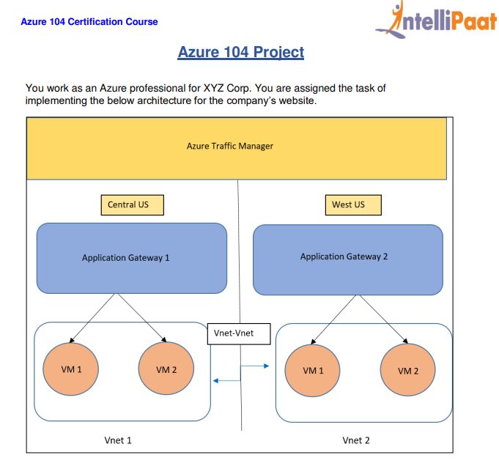

* Create 2 VM in central India and 2 VM in East US

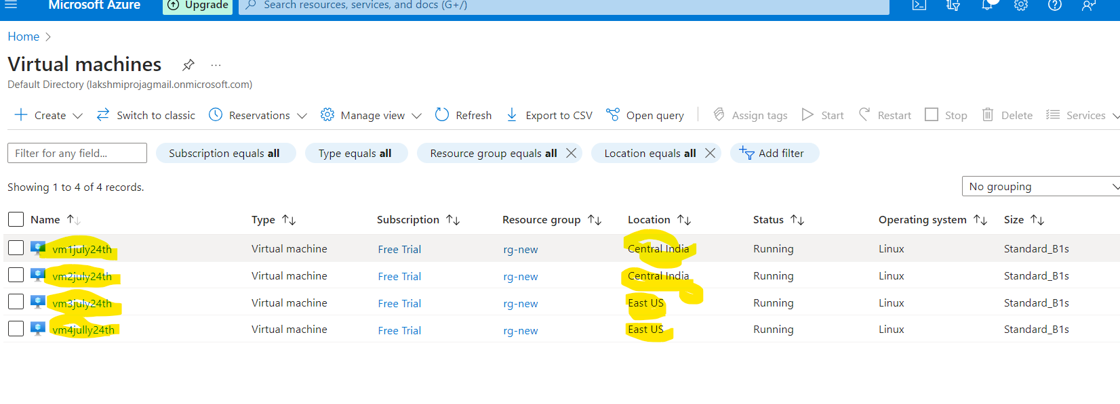

* Create a storage account
* Create a container with name as **Upload**

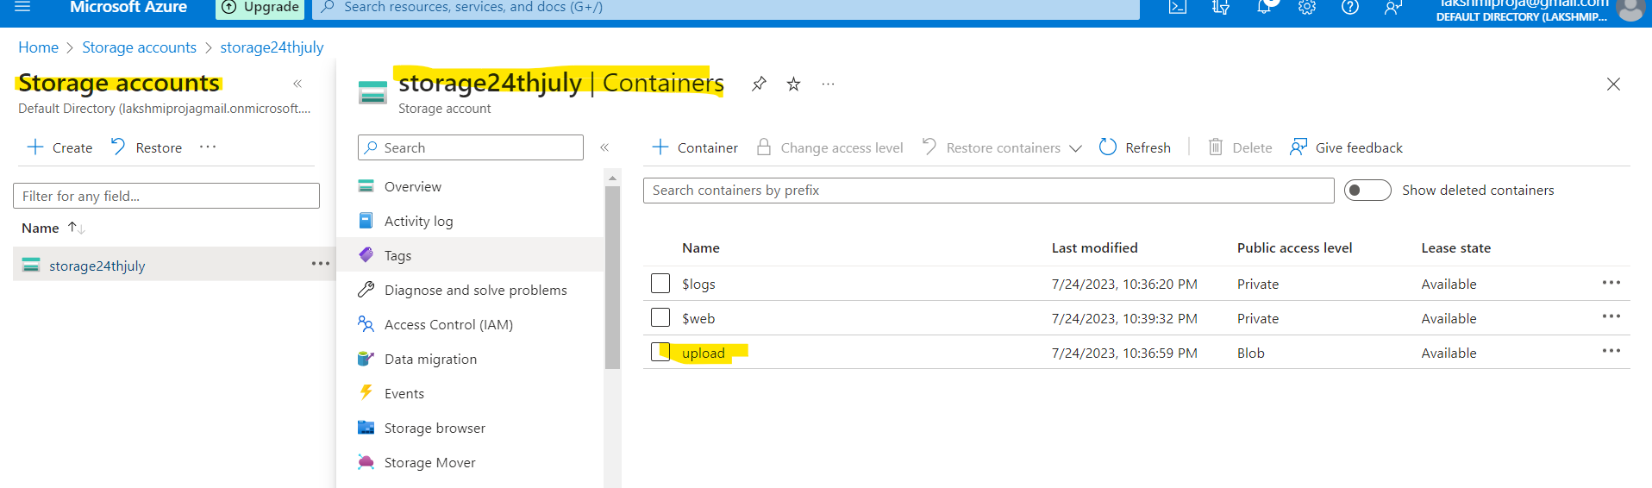

* Download the error.html file from the github repository
* You need to host your error.html as a static website as shown below

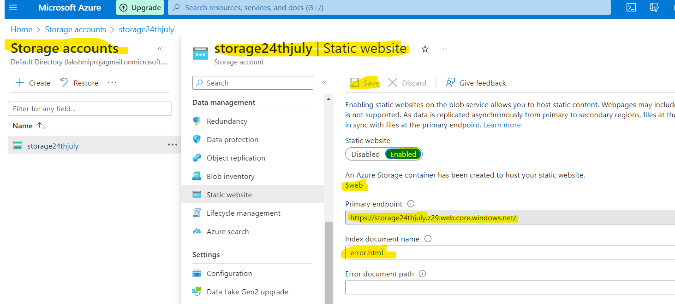

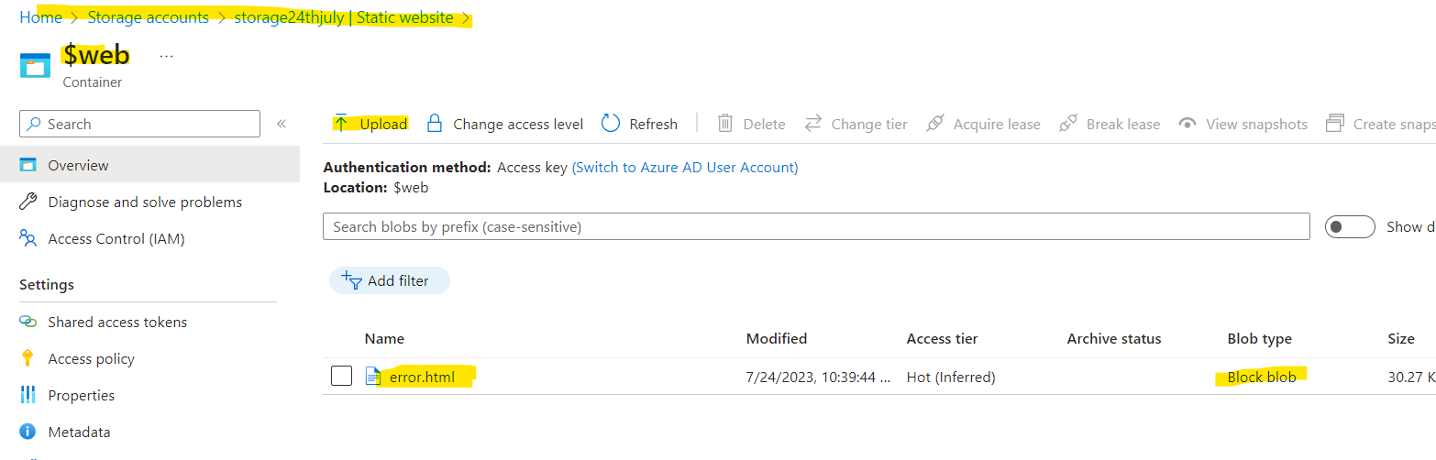

* Create application gateway in 2 different regions central india and east us.

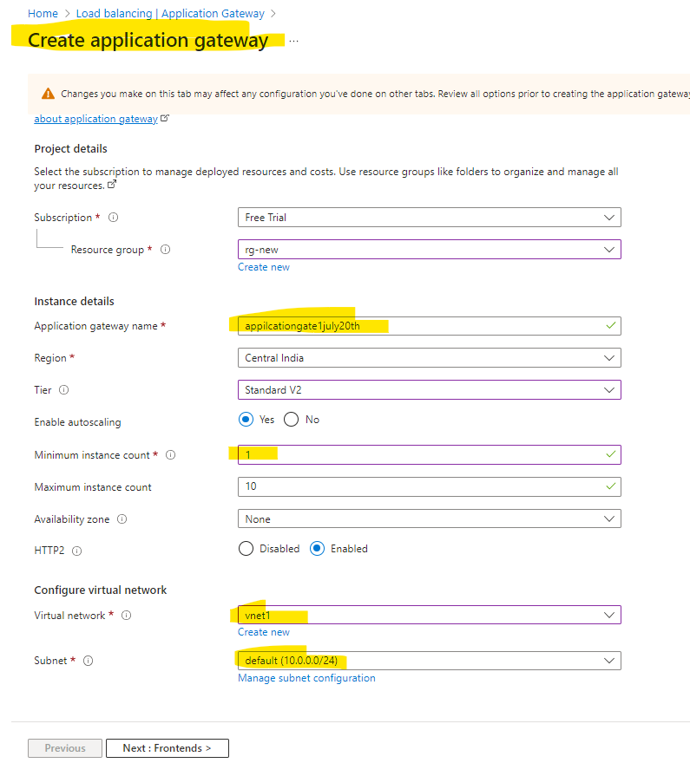

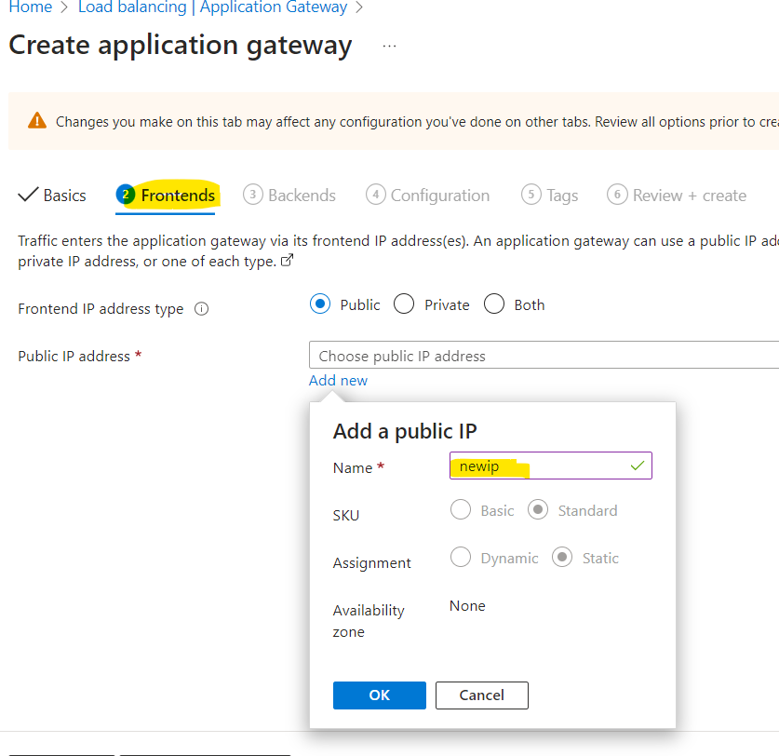

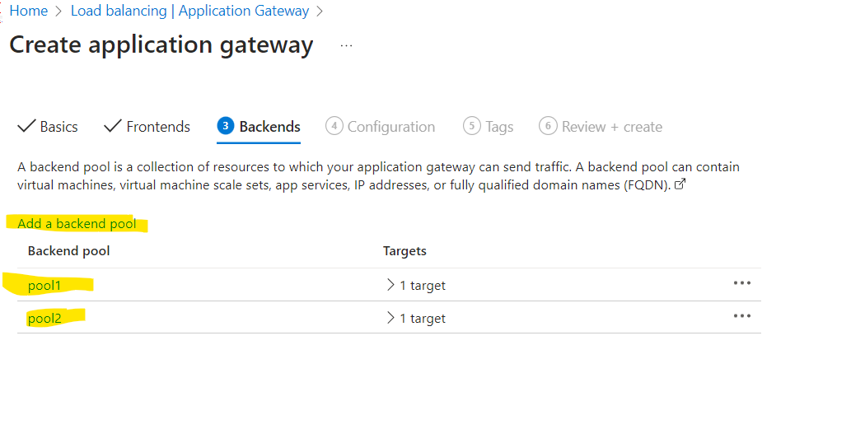

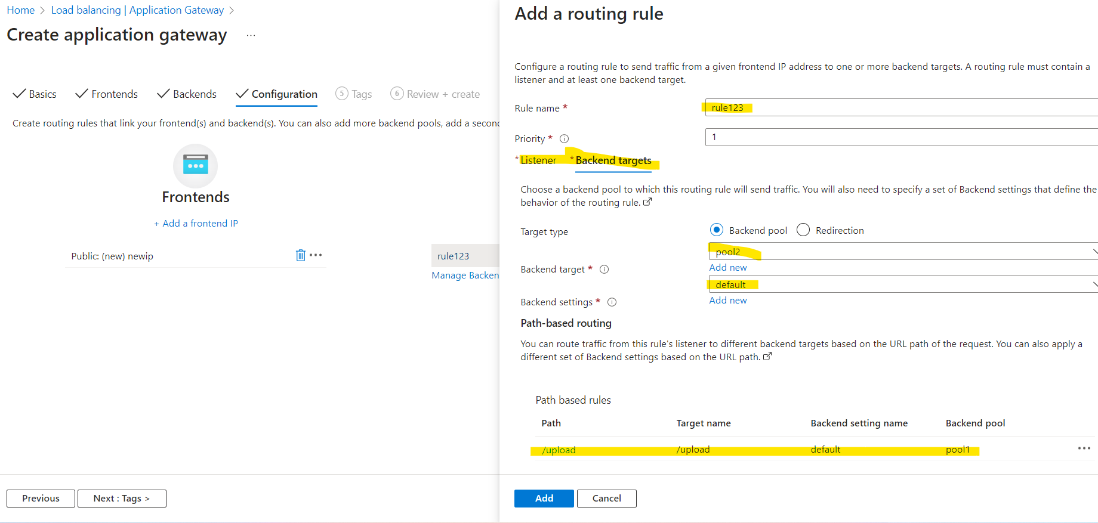

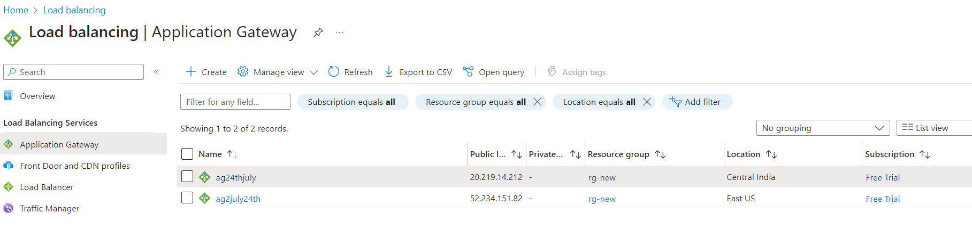

* Assign a DNS name to both the application gateways.

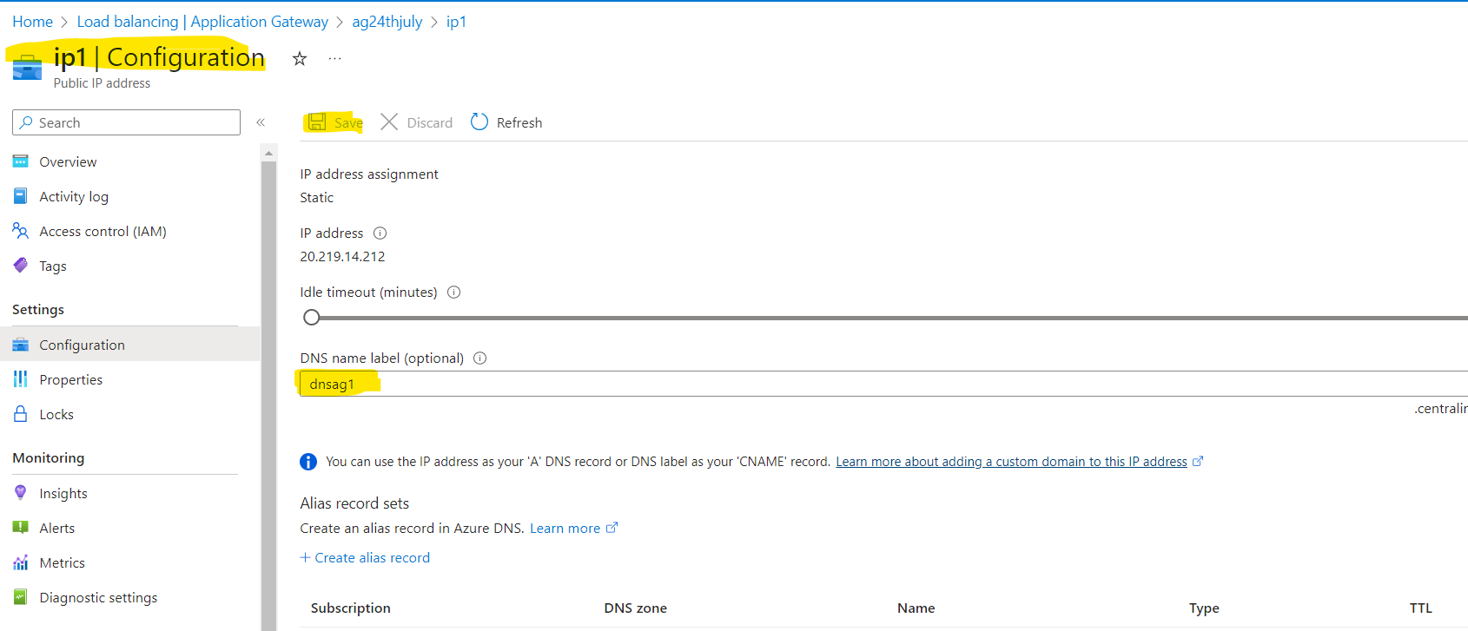

* 1. Deployments in both the regions, should have VMs inside VNets.
* 2. Clone the github repo https://github.com/hshar94/azproject to all the VMs.
* 3. On VM1, please run vm1.sh this will deploy the upload page, on VM2 please run VM2.sh, this will install the home page.
* 4. For running the scripts, please run the following command inside the github directory from the terminal.

**VM1: ./vm1.sh VM2:**

**./vm2.sh**

* 5. After running the scripts, please edit **config.py** file on VM1, and enter the details related to your storage account, where the files will be uploaded 6. Once done, please run the following command
* **sudo python3 app.py**

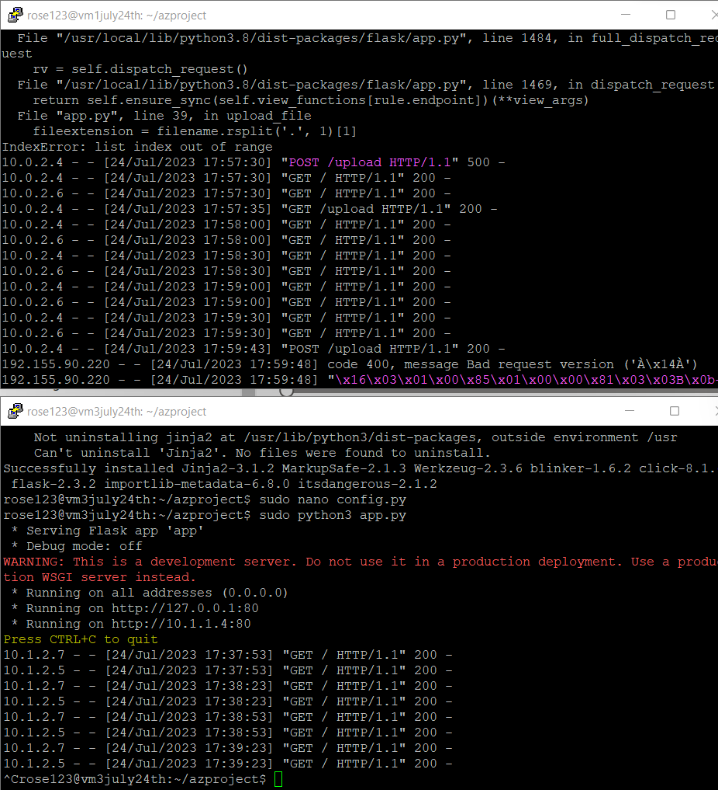

* Create a traffic manager and add 2 endpoints

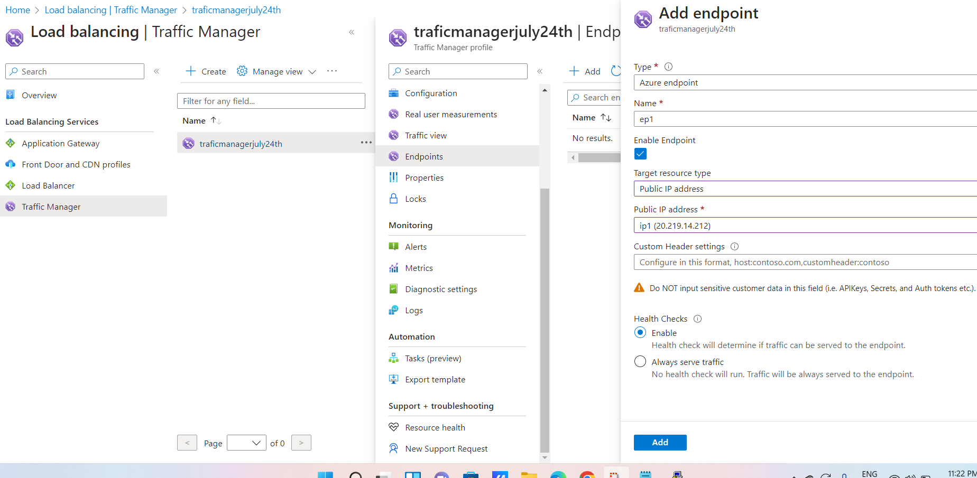

* Use the DNS name from the azure traffic manager and paste it in the browser to access the home page of the website.

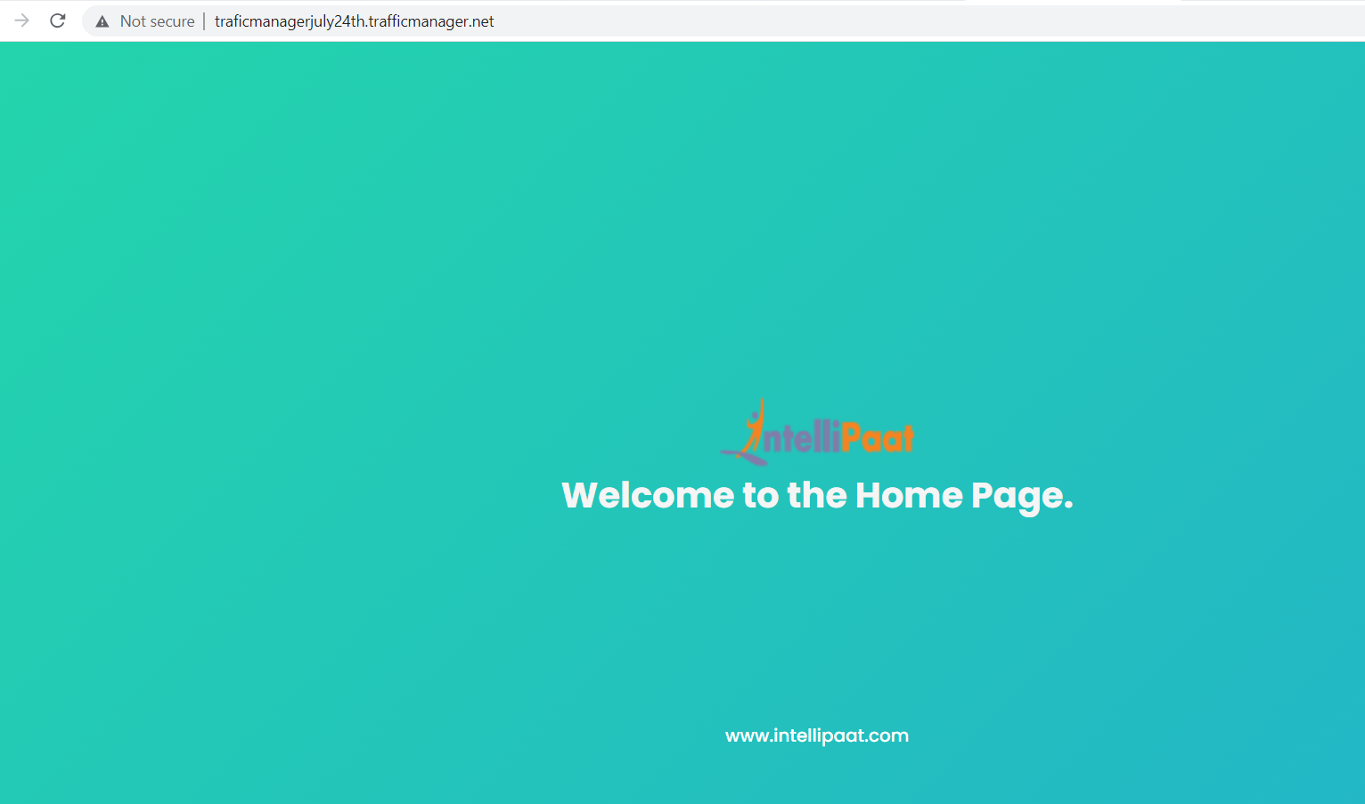

* The traffic is routed to vm1 when we use /upload to the given DNS name.

